Meap Car Design Overview

1. Engine Synthesis Layer

Synthesis Method
- Uses Wavetable Synthesis combined with Amplitude Modulation (AM) to simulate piston motion.

Oscillators
- osc_piston: Represents the core engine cycle. Frequency equals RPM.
- osc_body: Represents chassis resonance. Frequency equals RPM × 2.5 (texture_ratio).
- Output: The product of these two signals creates a rough, mechanical texture simulating engine combustion.

RPM Control
- Controlled by MIDI CC #1. Includes a friction algorithm to smooth value changes, simulating the inertia of a real flywheel.

Wind Noise
- White noise is generated when RPM > 10 and processed through a low-pass filter to simulate speed-dependent wind sound.

2. Generative Music Layer

Tempo Sync
- Music tempo is hard-synced to Engine RPM. As the car accelerates, the musical beat interval shortens (200ms → 80ms), creating an immersive audio-reactive experience.

Waveforms & Modes
Waveforms switch automatically based on the selected Touch Pad:
- Major: Sine Wave
- Minor: Triangle Wave
- Cyber: Sawtooth Wave
- Tension: Square Wave

3. Melody Generation Algorithms
The system features two layers: a Pad Layer (chords) and a Melody Layer (generative leads).

Core Logic
- Scales: Uses predefined arrays (scale_major, scale_minor, etc.) to ensure harmonic consistency.
- Entropy (Chaos): Controlled by Pot 1 (pot1_complexity), this parameter introduces controlled randomness into the generation algorithms.
Mode | Style | Base Logic | Entropy Effects (Pot 1)
Major | Ordered Arpeggio | Plays scale degrees 0, 2, 4, 6 in a loop (Root, 3rd, 5th, 7th). | >20: Inserts passing notes.  >60/90: Octave shifts (+12/+24 st) for rising intensity.
Minor | Sad/Lyrical | Focuses on Root (0) and 5th (3) notes on strong beats. | >20: Adds "fill-ins" on weak beats.  >70: Plays dissonant tones to create tension.
Cyber | Glitch/Bass | Octave down (-12 st). Plays on beats 1 & 3. | >30: Syncopation (off-beats).  >70: Glitchy octave jumps (+12 st) at end of bars.
Tension | Random/Horror | Trigger probability determined by 20 + pot1_complexity. | >50: Notes randomly jump across three octaves (low, mid, high) to maximize chaos.

4. Hardware Control Mapping

Pot 0: Envelope Release (Space)
- Controls the note Release Time (pot0_release), increasing the sonic decay for a reverb effect.

Pot 1: Complexity/Entropy (Chaos)
- The central algorithm modifier, mapped from 0 to 100, dictating the randomness and density of the generative music.

UI & Visualization (Max/MSP)

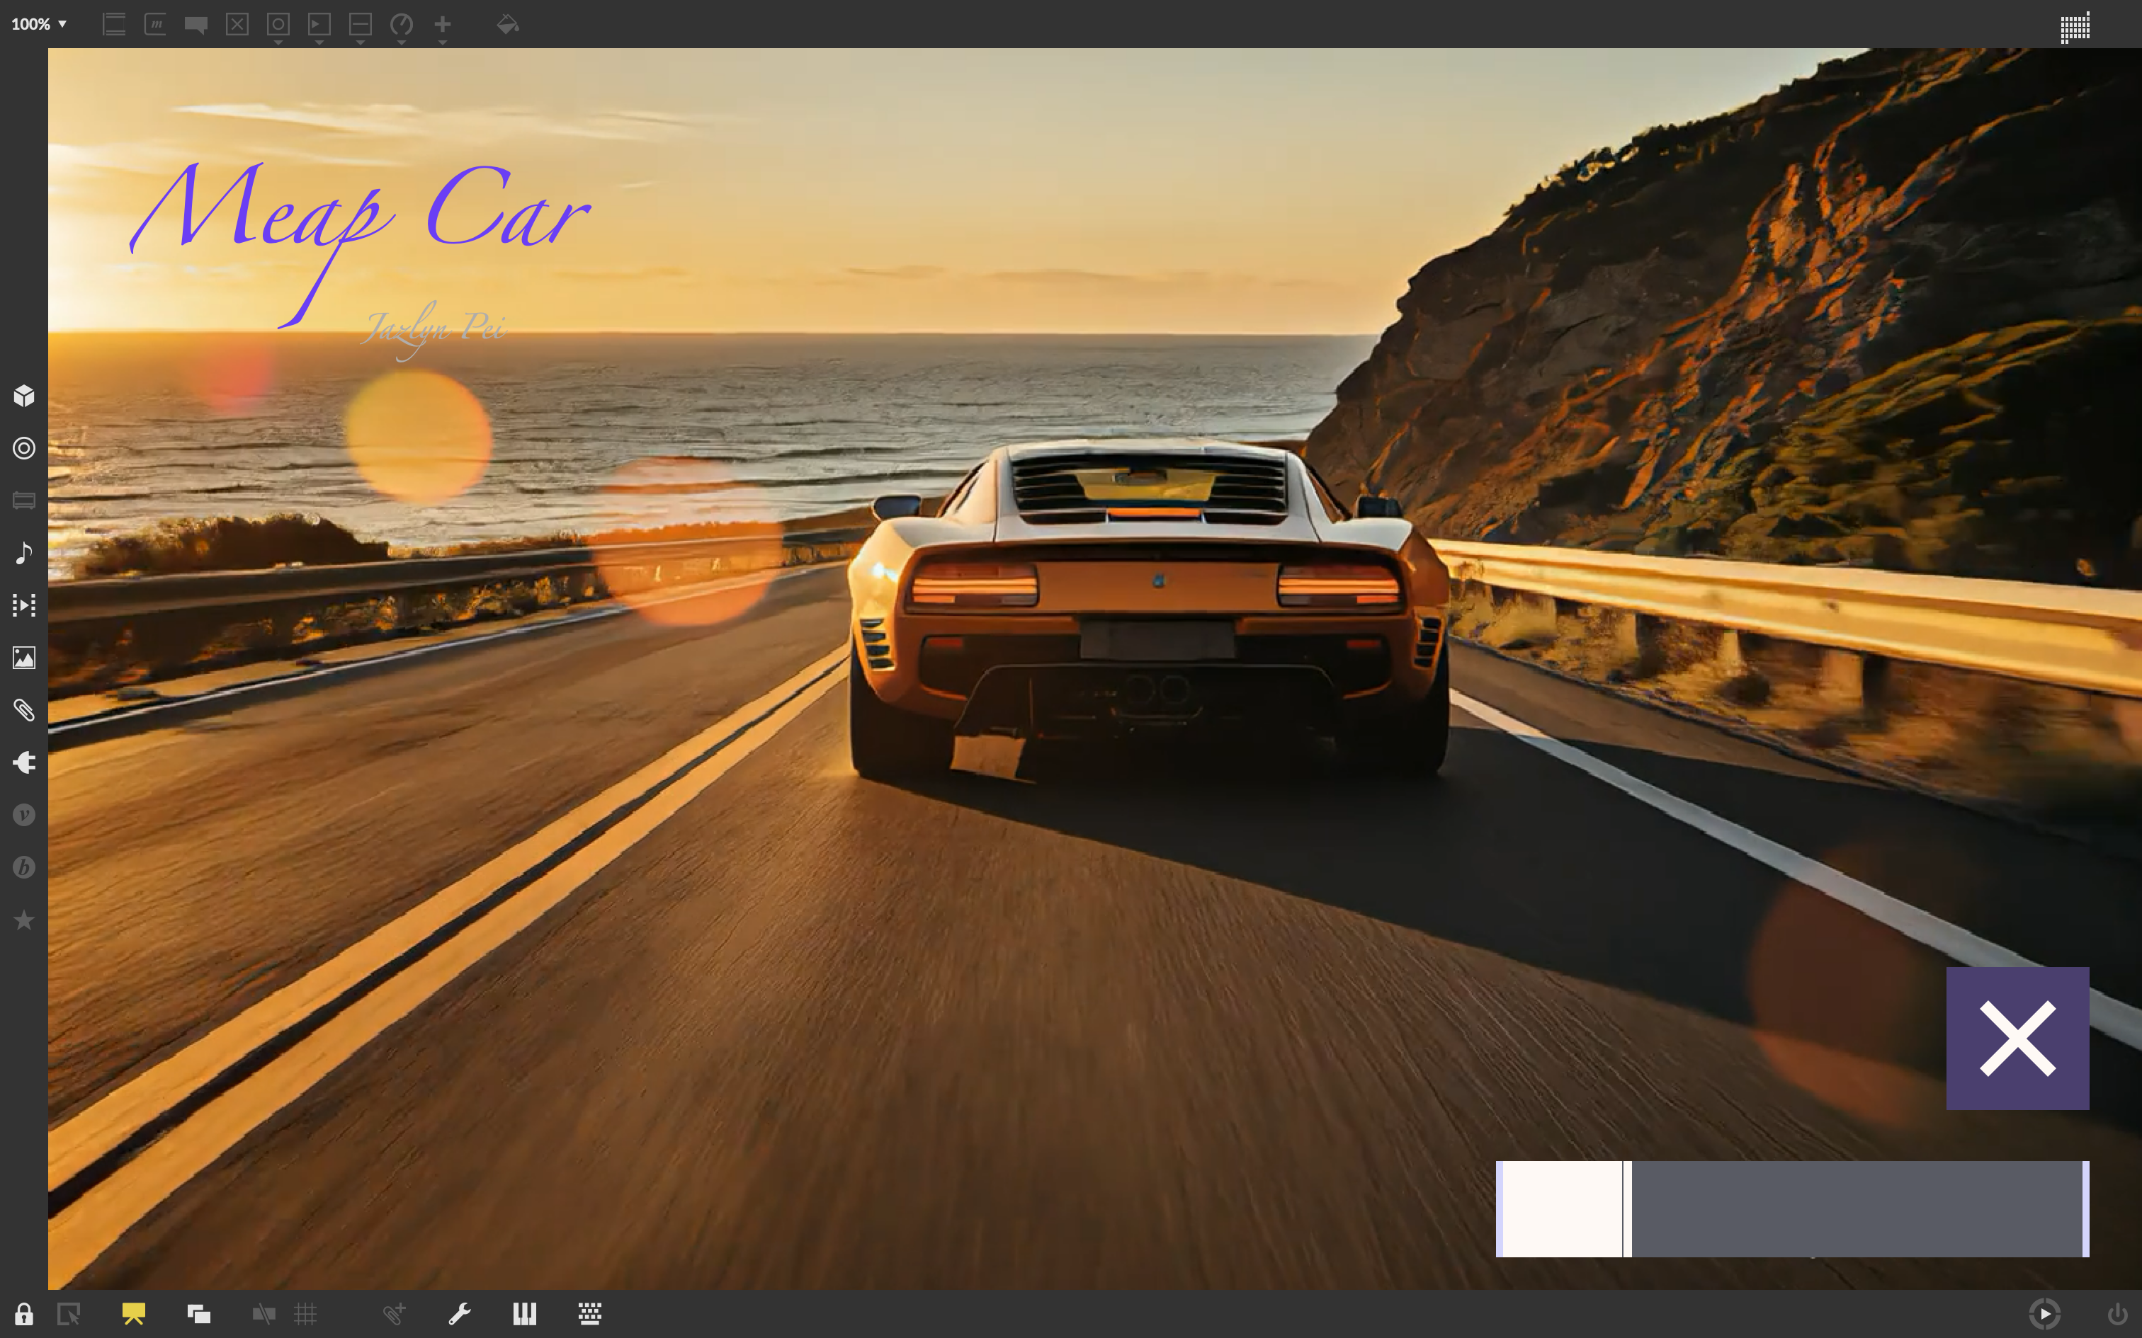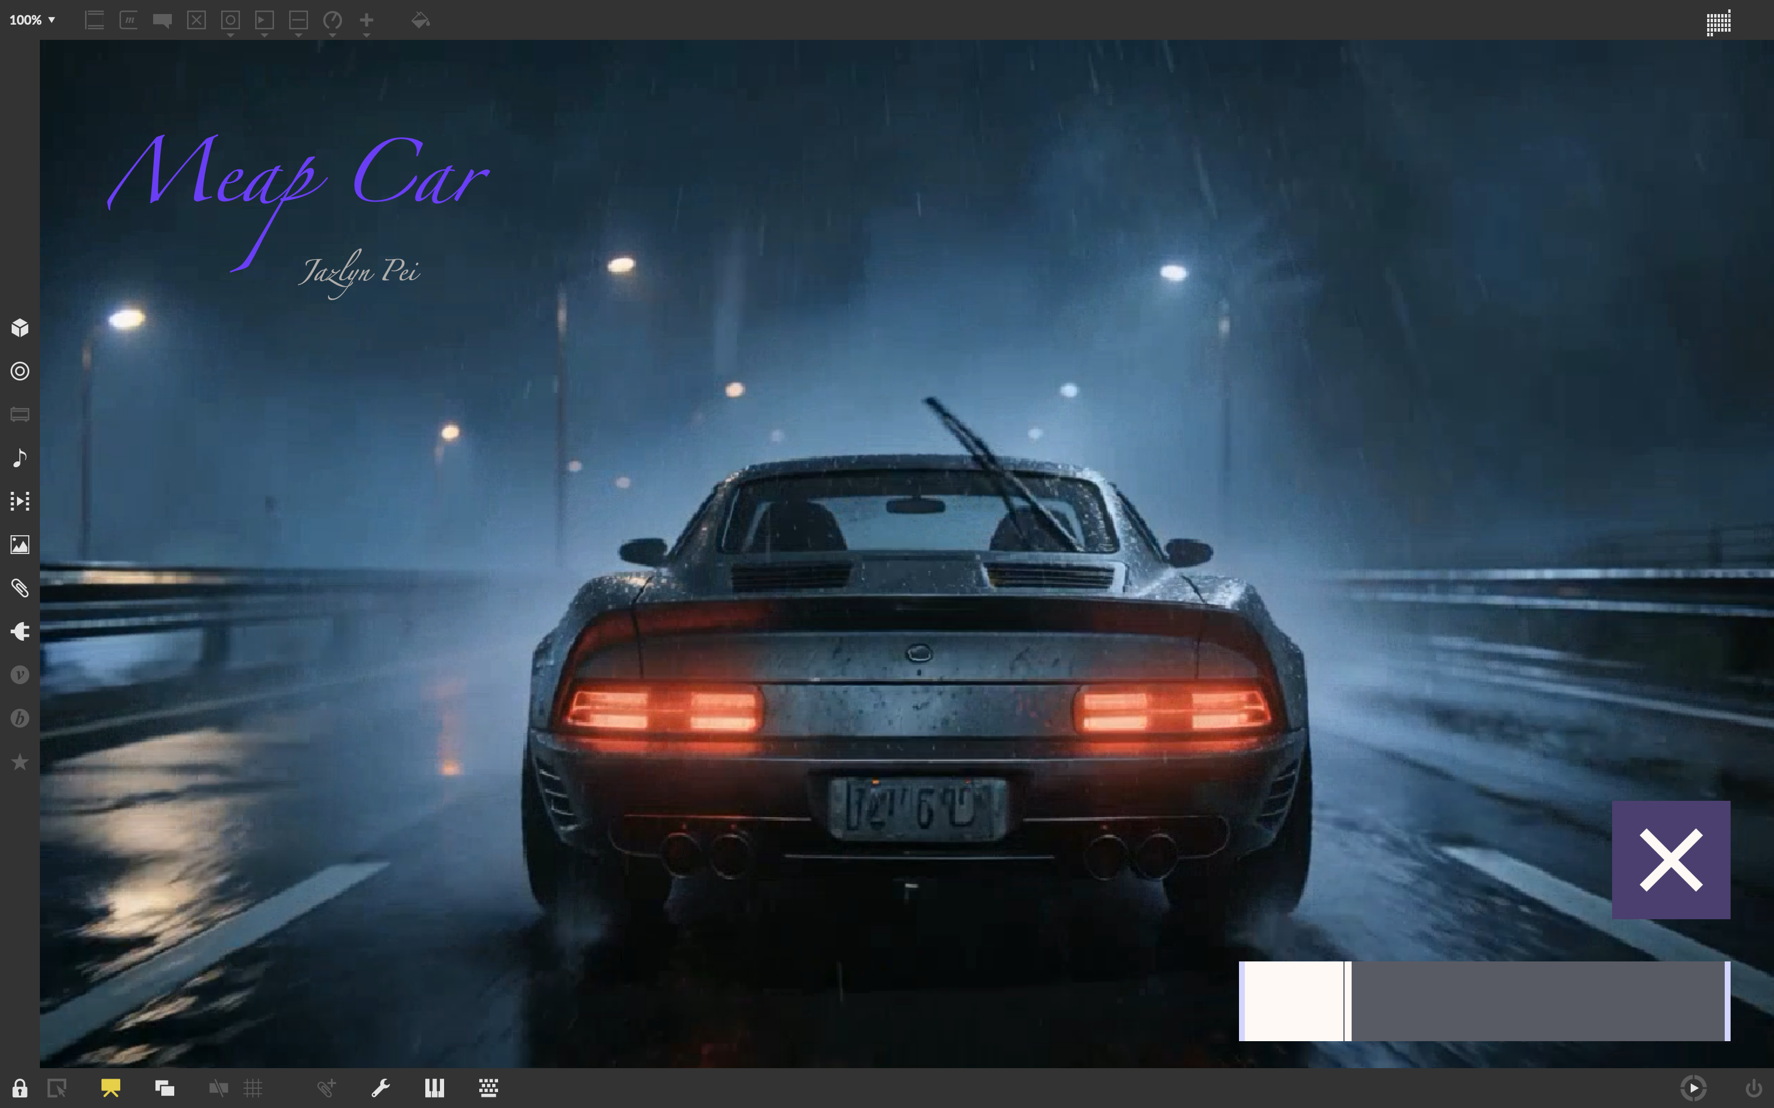
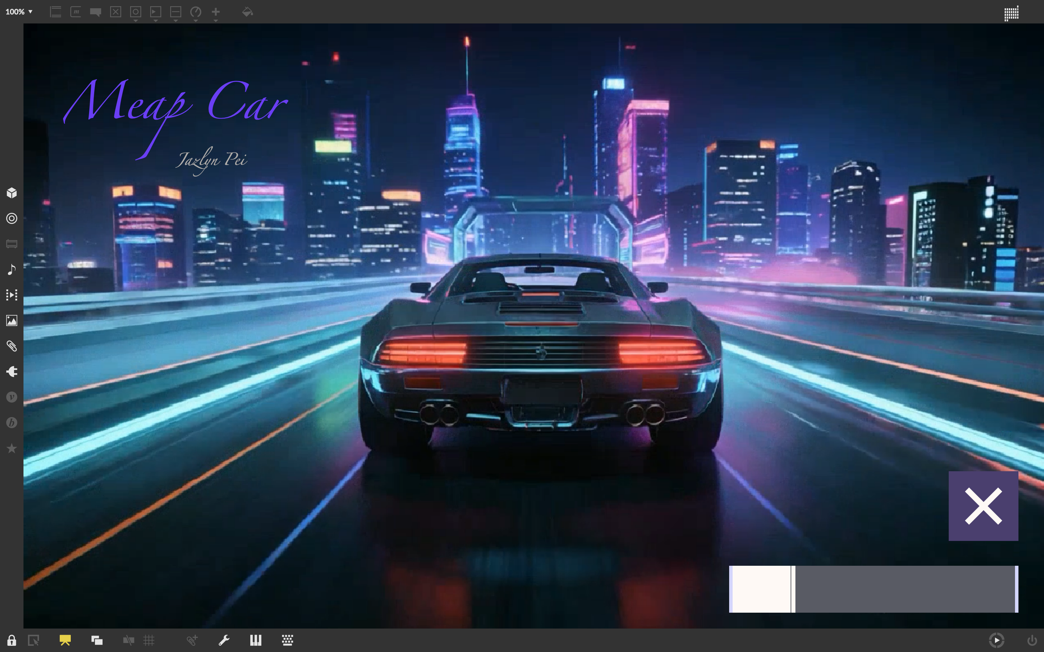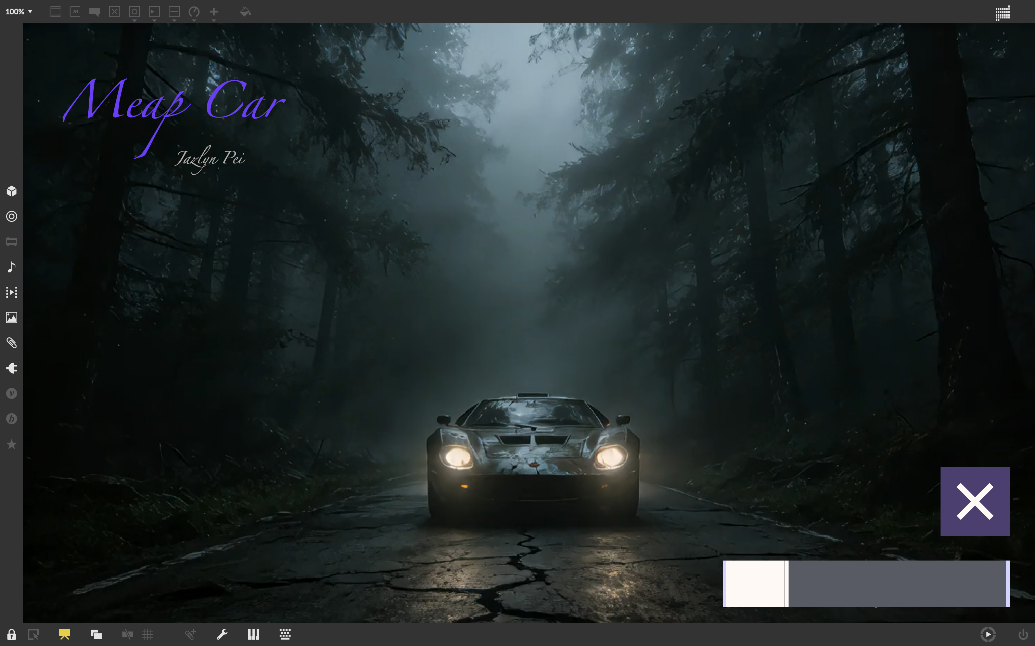
The Max patch handles video display, visual effects, and serial communication with the Meap board.

Communication
- Max uses Serial to receive SCENE (pad switch) and CHAOS (Pot 1 value) from the Meap.

Visual Response
- Scene Switching: Switching music modes triggers a cross-fade between four thematic video backgrounds.
- Throttle: Throttle control (ctlout2) adjusts the video playback rate to simulate acceleration.
- Strobe Effect: Linked to Pot 1 (Entropy). As complexity increases, a random-interval strobe effect is applied to the screen.

